# Lesson 9 Test the LCD1602 display

**Table**

1. Introduction of 1602 LCD 1

2. What do you need to prepare 3

3. Wiring 4

4. Upload the code and test 5

5. Code 7

6. Any questions and suggestions are welcome 8

# Introduction of 1602 LCD

I2C communication

I2C (Inter-Integrated Circuit) is a two-wire serial communication mode, which can be used for the connection of micro controllers and their peripheral equipment. Devices using I2C communication must be connected to the serial data (SDA) line, and serial clock (SCL) line (called I2C bus). Each device has a unique address and can be used as a transmitter or receiver to communicate with devices connected to the bus.

LCD1602 communication

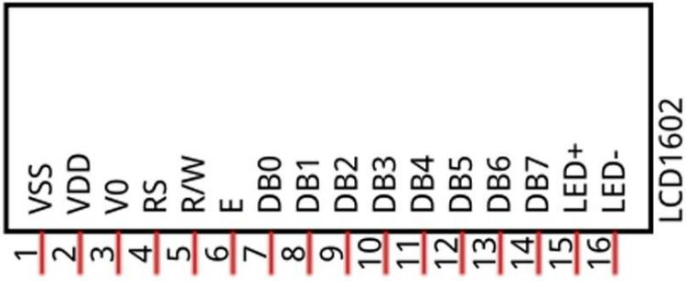The LCD1602 Display Screen can display 2 lines of characters in 16 columns. It is capable of displaying numbers, letters, symbols, ASCII code and so on. As shown below is a monochrome

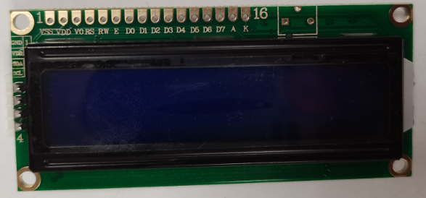

LCD1602 Display Screen along with its circuit pin diagram.

I2C LCD1602 Display Screen integrates an I2C chip, which connects the serial-input & parallel-output circuit to the LCD1602 Display Screen. This allows us to use only 4 lines to the operate the LCD1602.



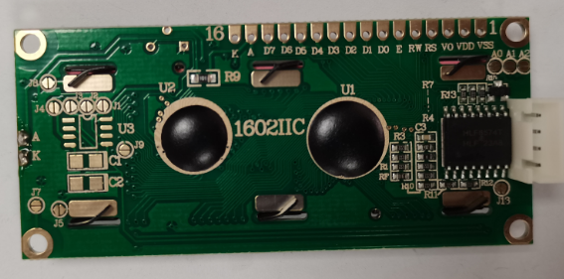

The serial-to-parallel IC chip used in this module is PCF8574T (PCF8574AT), and its default I2C address is 0x27(0x3F).

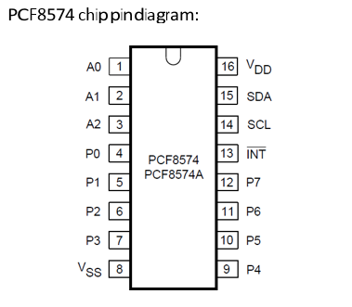

PCF8574 chip pin and LCD1602 pin are corresponding to each other and connected with each other:

So we only need 4 pins to control the 16 pins of the LCD1602 Display Screen through the I2C connector. In this project, we will use the I2C LCD1602 to display some static characters.

# 2. What do you need to prepare

|  |  |  |  |
| --- | --- | --- | --- |
| **Components** | **Quantity** | **Picture** | **Remark** |
| USB Cable | 1 |  |  |
| Control board | 1 |  |  |
| LCD1602 Display Module | 1 |  |  |
| 4-Pin wires | 1 |  |  |

# 3. Wiring

Use a 4pin cable to connect the interface of the 1602LCD module to the X3 interface on the control board, and then use a USB cable to connect the control board. You don't need to connect the 18650 battery for external power supply.

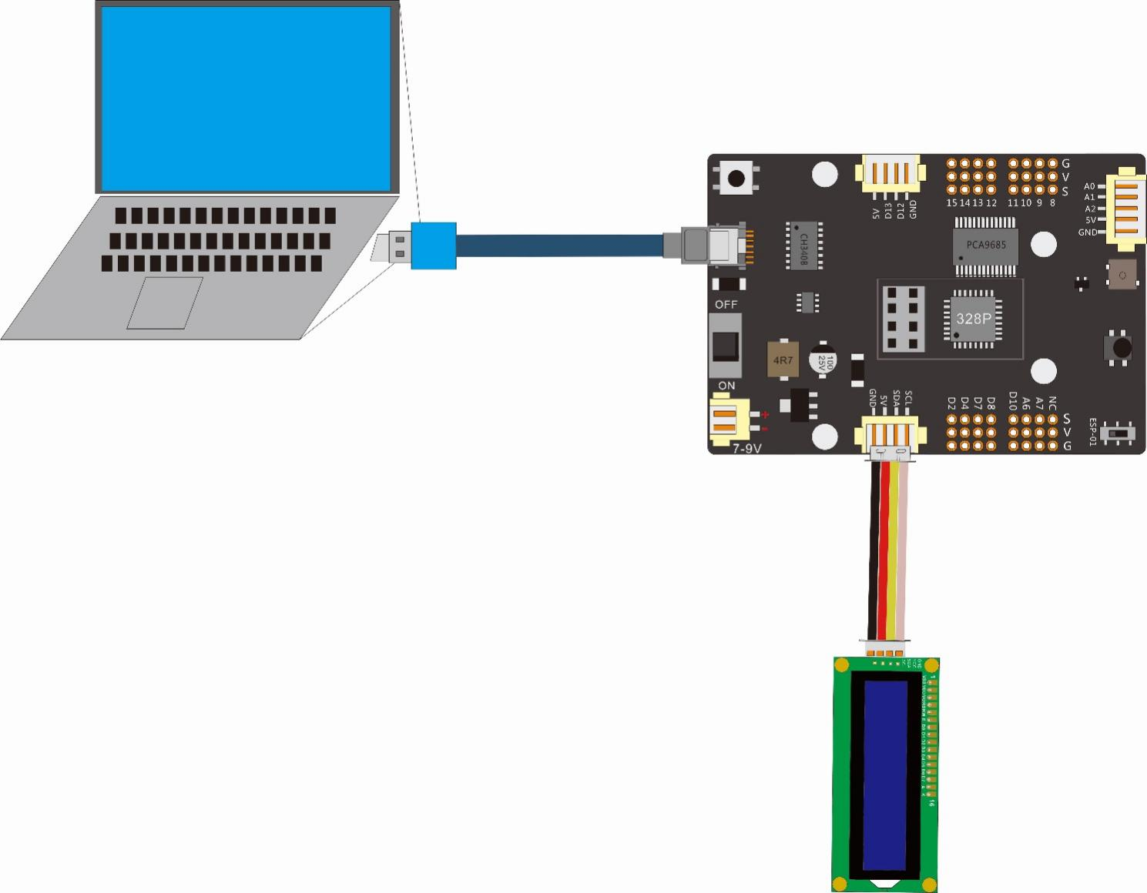

|  |  |
| --- | --- |
| Wiring between the LCD1602display and the control board | |
| Connector of LCD1602 display | X3 Connector of the control board |
| GND | GND |
| VCC | 5V |
| SDA | SDA |
| SCL | SCL |

# Upload the code and test

The code used in this lesson is placed in this folder：“ E:\CKK0002-master\Tutorial\sketches”

4.1 Double-click the Arduino IDE shortcut on the desktop to open it

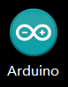

4.2 Click "File" --- "open"

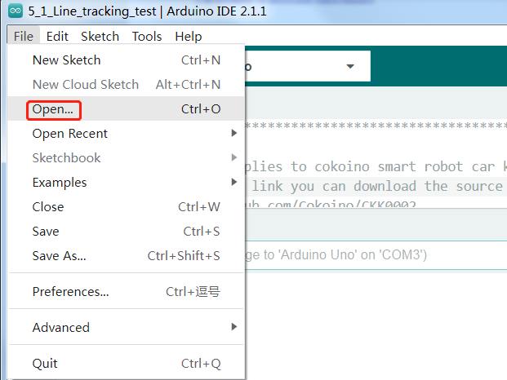

4.3 Select the code in the folder named 7_1_LCD_dispaly：

E:\CKK0002-master\Tutorial\sketches\7_1_LCD_dispaly，Click "open"

4.4 Select the board "Arduino UNO"and Port "COM3" (COM port is commonly known as an input output port for a device normally PC which enables communication between Arduino and PC. You can check your arduino com number in device manager, the com port of our arduino board is recognized as COM3 in this tutorial)

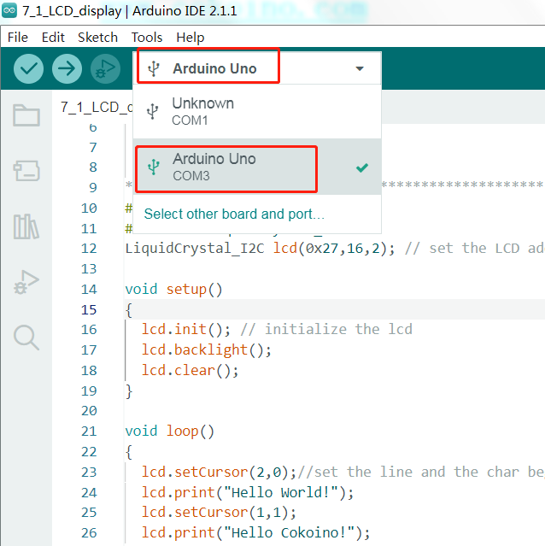

4.5 Install LiquidCrystal libraries

For the installation method, please refer to the method of installing the library file Servo.h in Lesson 4

* 1. Click compile button，successfully compiled the code will display “Done compiling”

4.7 Before uploading the code, turn the ESP-01 switch on the control board to the side away from the "ESP-01" silk screen.

4.8 Click upload button，successfully uploading the code will display “Done uploading”. When code is uploaded successfully, the program starts to run.

4.9 After the code is uploaded successfully, you can see two lines of text "Hello World!", "Hello Cokoino" displayed on the LCD display.

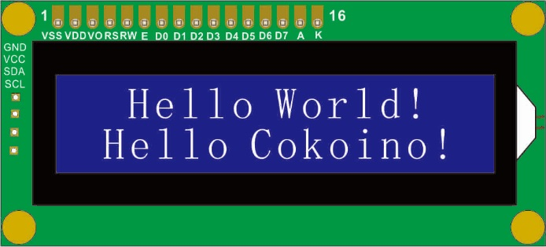

# 5. Code

**7_1_LCD_display.ino**

#include <Wire.h>

#include <LiquidCrystal_I2C.h>

LiquidCrystal_I2C lcd(0x27,16,2); // set the LCD address to 0x27 for a 16 chars and 2 line display

void setup()

{

  lcd.init(); // initialize the lcd

  lcd.backlight();

  lcd.clear();

}

void loop()

{

  lcd.setCursor(2,0);//set the line and the char begaining for the print information

  lcd.print("Hello World!");

  lcd.setCursor(1,1);

  lcd.print("Hello Cokoino!");

}

# 6. Any questions and suggestions are welcome

Thank you for reading this document!

If you find any errors and omissions in the tutorial, or if you have any suggestions and questions, please feel free to contact us:

[cokoino@outlook.com](mailto:cokoino@outlook.com)

We will do our best to make changes and publish revisions as soon as possible.

If you want to learn more about smart cars, robots, learning kits and other technology products from us, please bookmark and pay attention to our website:

<http://cokoino.com/>

We will continue to launch interesting, cost-effective, innovative, user-friendly products.

LK COKOINO